Long-term plan unit:  Unit 7. Travel and Transport |  |  |  |  | School:
Date: |  |  |  |  | Teacher name: Sulaimanova Aziza
CLASS: 8 |  |  |  |  | Number present: | absent:
Lesson title |  |  | My favourite place to visit
Learning objectives(s) that this lesson is contributing to (link to the Subject programme) |  |  | 8.2.1.1 understand with little or no support the main points in extended talk on a wide range of general and curricular topics  8.3.5.1 interact with peers to negotiate, agree and organise priorities and plans for completing classroom tasks  8.4.1.1 understand the main points in texts on a growing range of unfamiliar general and curricular topics, including some extended texts
Lesson objectives |  |  | All learners will be able to:  -understand the main idea of the video with little support  -give short answers about places they want to visit  -highlight the main idea of the text  -match the place names with the picture  Most learners will be able to:  -discuss and exchange own ideas on the text  -ask questions to interact in groups  Some learners will be able to:  -negotiate about their favourite places to visit with other learners  -plan and organise their future trip using specific vocabulary
Assessment criteria |  |  | Provide unprepared speech to answer the questions on topic  Match the pictures with the place names  Highlight the main idea of the text  Plan a trip using specific vocabulary  Work in group and with peers  Interact with each other through reading and discussion
Level of thinking skills |  |  | Higher order thinking skills
Values links |  |  | Common history, culture and language
Cross-curricular links |  |  | Geography
Previous learning |  |  | Around the world
Plan
Planned timings | Planned activities (replace the notes below with your planned activities) |  |  |  |  |  | Resources
Start  8min | - Beginning of the lesson:  Teacher greets learners, introduces to the learning objectives.  Brainstorming Strategy. Teacher asks to find out the topic of the lesson by watching the video “My favorite place: The Park”  After that teacher asks the following questions:  -What was the video about? How do you think what are we going to talk about ?  -What is your favorite place to visit in Shymkent?  -What would you suggest a visitor should see and do in your country?  Teacher and learners discuss the questions all together.  - Dividing the class into three group |  |  |  |  |  | https://www.youtube.com/watch?v=gLZBd7RezgE  Stickers
20min  10min | Task 1. Teacher gives the text “Places of interest in London” for reading and discussing.  Pre-reading task. The teacher will ask the learners if they know what famous places they can visit in London. The learners will see some pictures of famous places from London. Teacher asks learners to work in peers to match the place names with the picture of famous places (Big Ben, London Eye, Buckingham Palace Houses of Parliament, Madame Tussauds, Tower Bridge)    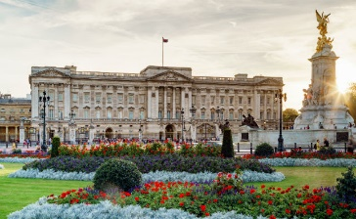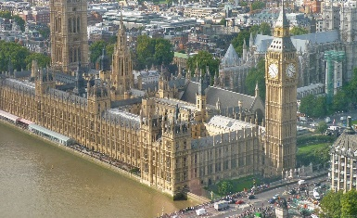  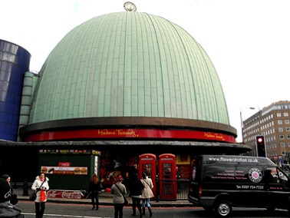  After they will finish they will get the answers and correct themselves if it is necessary.  Self-assessment  While reading task. Selective Highlighting Strategy. Teacher asks learners to highlight only the most important key words in the text for getting main idea.  Post reading task. Learners will use an active learning structure such as Round Robin Consensus to discuss and justify their underlined selection. Work in group. Each group chooses a leader whose task will be to present the results. In each group one learner leads the discussion, then each learner takes his turn telling their opinion on the highlighted word, one student will be assigned the recorder where his job is to record everything that each learner says. After that the leaders of each team will present their group’s ideas.  Descriptor  1)Highlight the main idea of the text  2) Interact with each other through reading and discussion  3) work in group  4) Express group’s idea  Group assessment: three groups assess each other by giving colourful star stickers  Differentiation by: supporting with more able learners. Less able learners allowed to use dictionary for key words, more able learners allowed to use “helper activity” around the group to support weak learners.  Task 2.  - The teacher asks learners what things they would have to consider if they were planning a trip. Teacher tries to elicit such information as accommodation, food, transport, places to visit things to pack etc.  - Teacher gives worksheets from which they can get information and specific vocabulary that could help them to plan their trip.  - Learners should organize a trip in peers and present their result to the class. After the presentation of each peer, other learners have possibility to ask questions if something is not clear.  Descriptor  1)Plan a trip using specific vocabulary from worksheet  2)work in peer  Whole class assessment. At the end teacher asks learners to give a vote to the peer whose trip was the best organized. Teacher announces each peer and learner who liked the trip of certain pair rises his hand. Teacher counts voices (raised hands) and determines the best peer work.  Differentiation by worksheet. Worksheet will help learners to plan a trip. Teacher monitors students while they plan a trip, offering encouragement and support where necessary. |  |  |  |  |  | http://engmaster.ru/topic/1864  pictures  Stickers    Worksheet  https://en.islcollective.com/resources/printables/worksheets_doc_docx/planning_a_trip/future-tenses-travel/71144
End  2min | Feedback:    Learners stick their stickers on the “Progress Thermometer” hanged on the wall which shows their effects about the lesson.  Home task: write essay on topic “My favorite place to visit”.
Additional information
Differentiation – how do you plan to give more support? How do you plan to challenge the more able learners? |  |  |  | Assessment – how are you planning to check learners’ learning? |  |  | Health and safety check
Differentiation by: supporting with more able learners. Less able learners allowed to use dictionary for key words, more able learners allowed to use “helper activity” around the group to support weak learners.  Differentiation by worksheet. Worksheet will help learners to plan a trip. Teacher monitors students while they plan a trip, offering encouragement and support where necessary.  Teachers support  will be given during the whole lesson in completing each task. |  |  |  | Learners speaking and reading abilities are assessed in group and in class and teacher evaluates them by asking additional questions.  Task 1. Self-assessment by key answers.  Group assessment. Groups are evaluated by giving colorful stars stickers to each other.  Task 2. Learners are evaluated by whole class assessment. |  |  | Be careful with electric current while displaying video.
Reflection  Were the lesson objectives/learning objectives realistic?  Did all the learners achieve the lesson objectives/ learning objectives? If not, why?  Did my planned differentiation work well?  Did I stick to timings?  What changes did I make from my plan and why? |  | Use the space below to reflect on your lesson. Answer the most relevant questions from the box on the left about your lesson.
Summary evaluation

What two things went really well (consider both teaching and learning)?

1:

2:

What two things would have improved the lesson (consider both teaching and learning)?

1:

2:

What have I learned from this lesson about the class or individuals that will inform my next lesson?

